1 pole processing

1. Can extend the end to designated location with mesh connected to original model
2. Can pick special dent region material
3. Can generate spring connected loading plate
4. Can specify support nodes

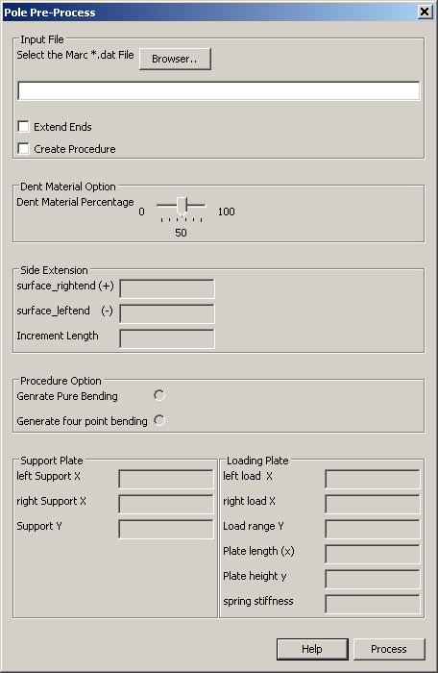

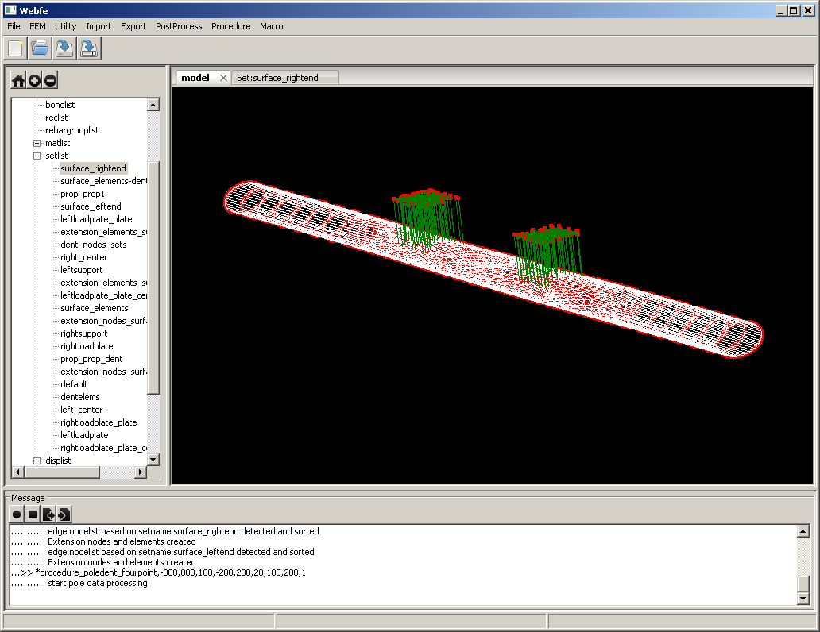

2 t16 file processing ability

1. Make post requests

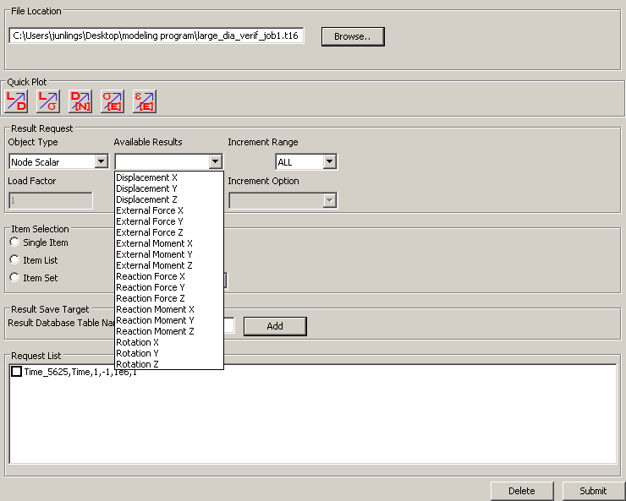

1. Go over available results

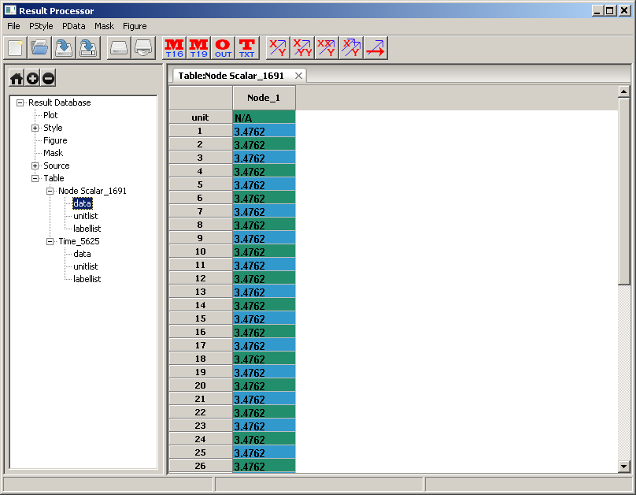

1. Make plots

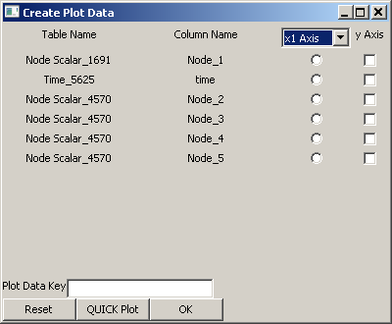

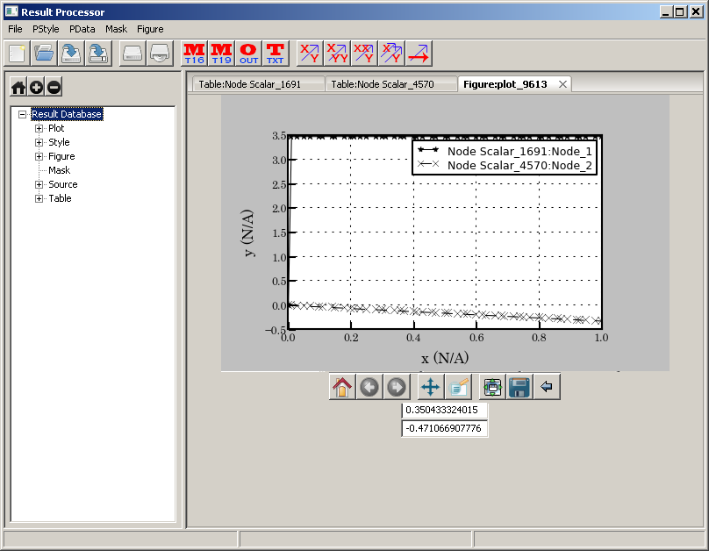

Generated figures can be exported in both \*.jpg and \*.eps format

d) Plain text reading function to process the DAQ generated result files

